**Project Milestone of Gluttonous Snake game**

**COMPT_220L shuhan**

**Abstract**

The game is simple and fun, so I want to try to use java as a simple snake, use the keyboard to control the direction, through the observer mode, the snake will respond accordingly when the player presses the button.

**Introduction**

Application scenario: The keyboard listener uses the observer mode. The observer is a snake. The observer is the keyboard button. The player presses the “up, down, left and right” direction keys on the keyboard. When the observer changes, the observer Being able to get the message in time and respond accordingly, the snake will respond to this button event in time, and then go in the corresponding direction.

**Detailed System Description**

1. Observer - Snake (judge whether the snake has the isEat function of eating food, determine whether the snake exceeds the limit of the isOut function, determine whether the snake's head touches its body's isPitch function, and a snake exits the program after death. Dead function.)

2. The object associated with the snake - food (the constructor initializes the x, y coordinates and the flag flag. When the snake's head touches the food, that is, the snake's head or the coordinates of the body and the coordinates of the thing, it means that the food is eaten.)

3. Observer and map-window components and keyboard events (MyPanel class) (paint function is the snake's head, body, food fill color, call the fillRect and setColor functions in the Graphics class; keyPressed, used here two the secondary listener converts the button event into the change of the direction of the snake head for the first time, and transforms the change of the direction of the snake head into the change of the actual direction of the snake head for the second time.

4. Main function - application (GreedySnake class) (initialize the position of the snake head, initialize the position of the food, initialize the thread, and then add the keyboard listener whose parameters are mp, set some control panel related content

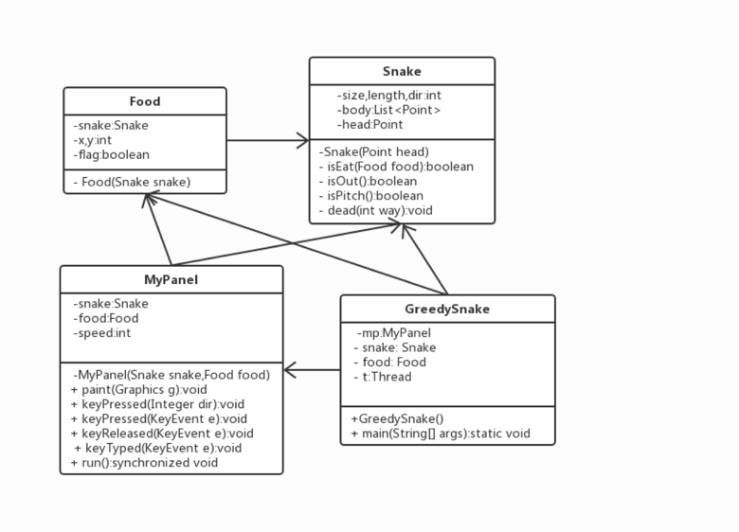

**Requirements**

I need to introduce some packages that I need to use，but Eclipse say it is wrong.

And I want to change the pattern of the game snake to make the game more interesting.

**Literature Survey**

I want to know more about the graphical user interface(GUI), So I am studying this part myself.

**User Manual**

Use the up, down, left and right to control the direction of the snake, find something to eat, every time you eat a bit you can get a certain score, and the snake body will eat longer and longer, the longer the body is, the more difficult it is to play, cannot touch the wall, cannot bite Your own body, you can't bite your tail

**Conclusion**

To make a simple and playable snake game.

**References/Bibliography**

**《Java Basics》 Tsinghua University Press**